# Correspondence Analysis

## Survey Question

### 

## Data : ca.csv

|  | Acceptable Price | Good Service | Good Taste | High Nutritional Value | Good Delivery Service | Large number of meal choices |
| --- | --- | --- | --- | --- | --- | --- |
| McDonald's | 98 | 38 | 72 | 0 | 48 | 68 |
| KFC | 75 | 26 | 44 | 3 | 21 | 29 |
| Burger King | 63 | 29 | 65 | 8 | 11 | 34 |
| Marrybrown | 58 | 23 | 25 | 4 | 10 | 28 |
| Shake Shack | 21 | 75 | 86 | 7 | 7 | 29 |
| MOS Burger | 35 | 39 | 57 | 23 | 8 | 29 |
| Five Guys | 30 | 62 | 78 | 10 | 11 | 29 |

## Pearson's Chi-squared test

data: cora

X-squared = 241.43, df = 30, **p-value < 2.2e-16**

**Very low p-value indicates statistically significant relationship**

## Fitting

> fit <- ca(obj=cora)

> summary(fit)

Principal inertias (eigenvalues):

dim value % cum% scree plot

1 0.125012 73.3 73.3 ******************

2 0.029803 17.5 90.8 ****

3 0.010402 6.1 96.9 **

4 0.003675 2.2 99.0 *

5 0.001639 1.0 100.0

-------- -----

Total: 0.170530 100.0

**Two dimensions explain 90.8%**

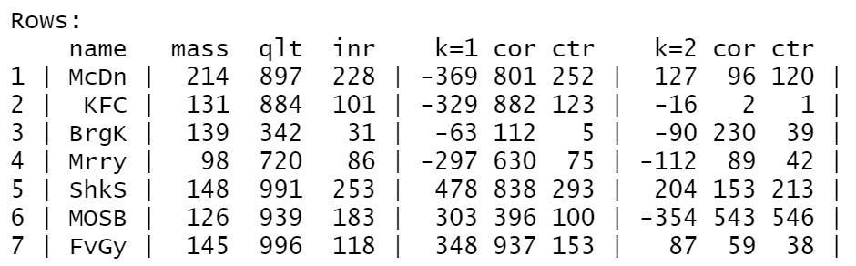

**Biggest contributors and opposite ends**

**1st dimension: Shake Shack and Mcdonald’s**

**2nd dimension: MOS Burger and Shake Shack**

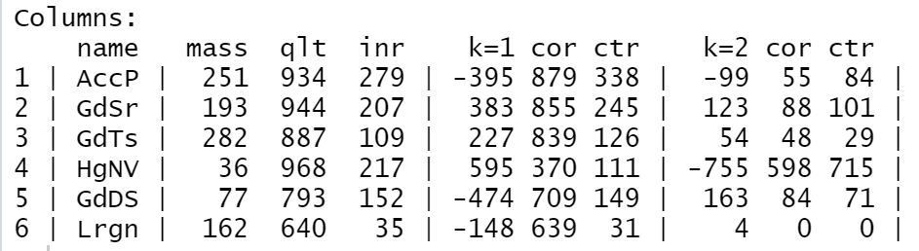

**Biggest contributor**

**1st dimension: Price**

**2nd dimension: Nutritional value**

## Plot

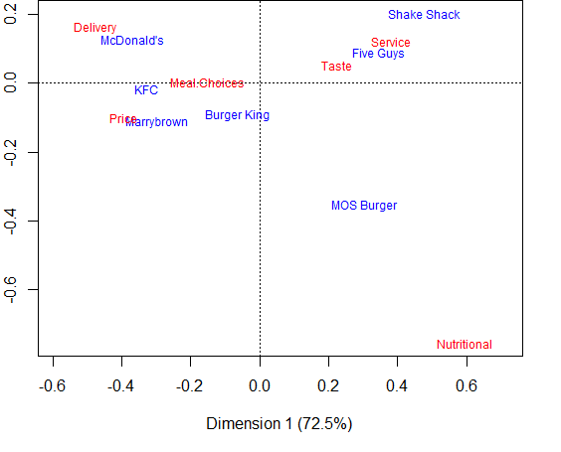

# MDSpref (96 respondents only)

## Survey Question

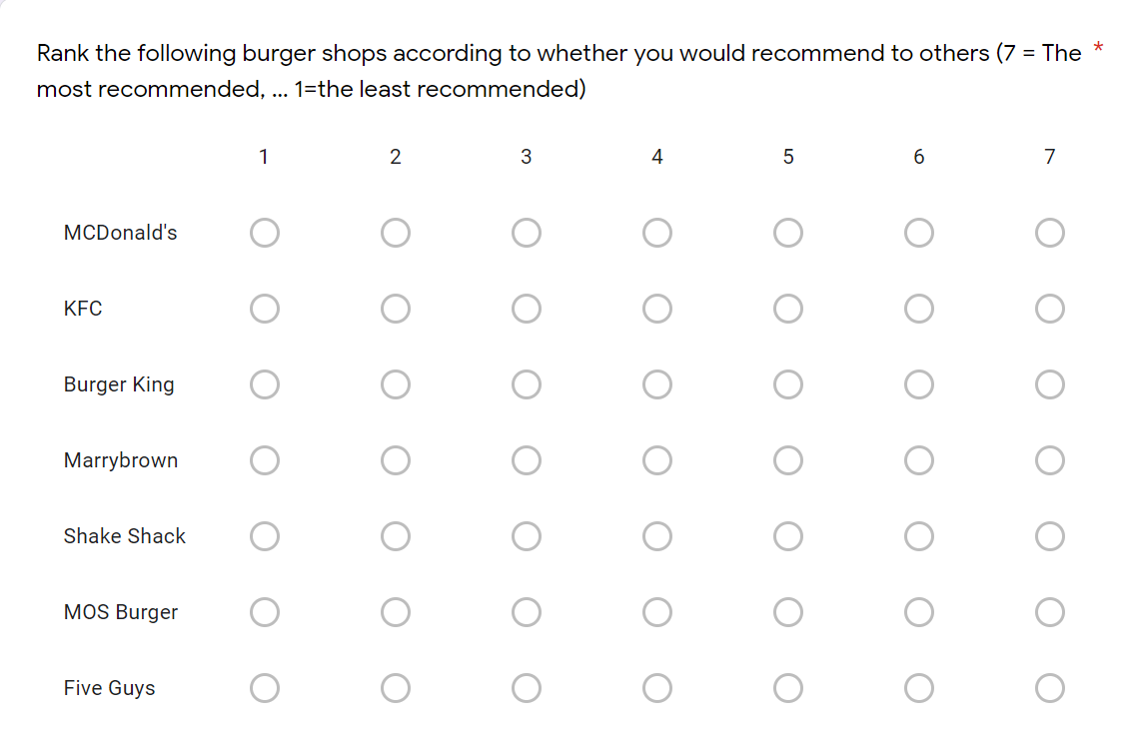

**Cmdpref function returns an error when all restaurants have the same rating. After excluding such responses, analysis on the remaining 96 responses has been done.**

## Plot

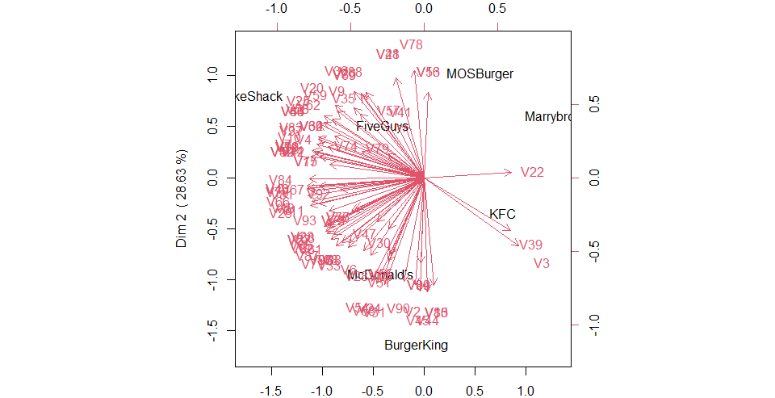

# MDS

## Survey Question

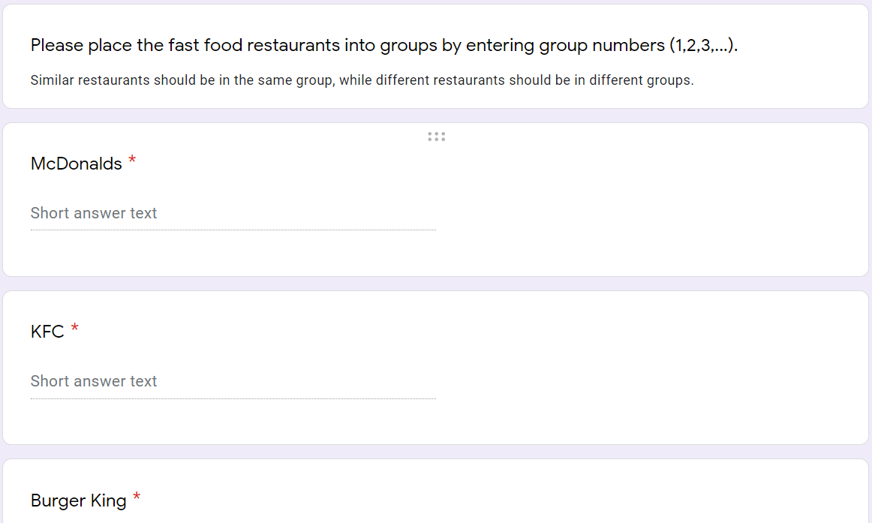

## Data

responses <- read.csv(“responses100.csv", header = TRUE)

groups <- t(responses[,53:59])

## Distance Matrix

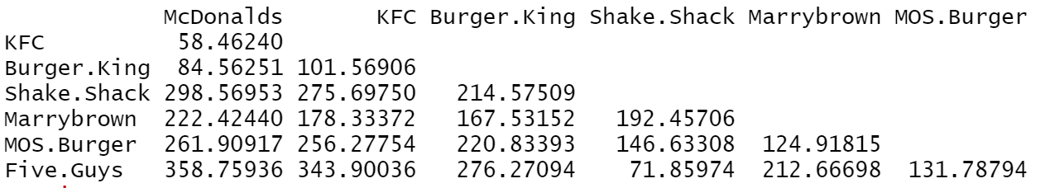

## > summary(mds.fit)

Configurations:

D1 D2

McDonalds -0.8022 -0.1013

KFC -0.6914 0.0536

Burger.King -0.4176 -0.2372

Shake.Shack 0.5639 -0.3097

Marrybrown 0.0391 0.4176

MOS.Burger 0.4314 0.2812

Five.Guys 0.8768 -0.1042

Stress per point (in %):

McDonalds KFC Burger.King Shake.Shack Marrybrown MOS.Burger Five.Guys

18.52 17.22 36.93 6.47 7.78 6.58 6.49

## > mds.fit

Call:

mds(delta = dist, ndim = 2, type = "ordinal")

Model: Symmetric SMACOF

Number of objects: 7

**Stress-1 value: 0.002**

Number of iterations: 11

## Plot

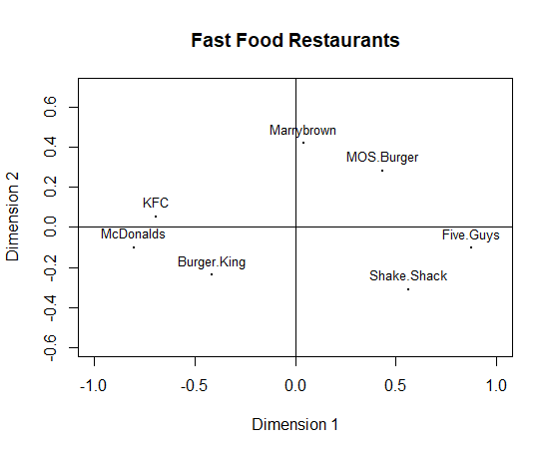

**Dimension 1: Value**

**Dimension 2:**

